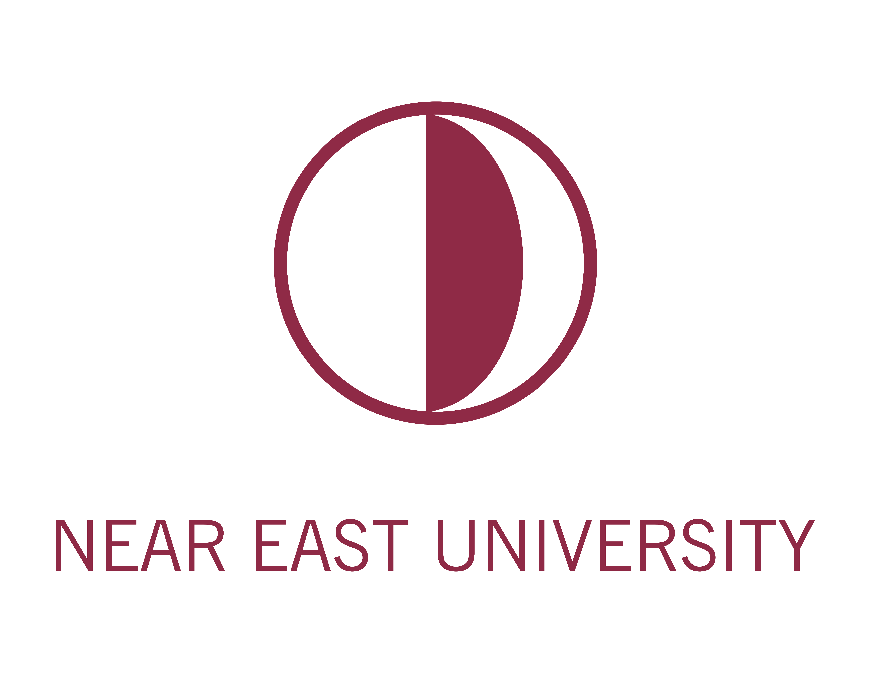

STUDENT EXCHANGE PROGRAM
FACTSHEET
ACADEMIC YEAR 2021/2022

Nicosia

https://www.visitncy.com/

NEU Campus

General Information

University Name | Near East University (NEU)
Website | https://neu.edu.tr/?lang=en
Address | Near East Boulevard  ZIP: 99138  Nicosia / TRNC  Mersin 10 - Turkey
Contact Person | Asst. Prof Rana Serdaroğlu Tezel  International Marketing Communication Manager/ International Office Program Coordinator / Lecturer, Faculty of Economics and Administrative Sciences  Reşat Şaban  International Development and Accreditation Coordinator  international@neu.edu.tr
Academic Calendar | Details on the 2021/2022 calendar  https://neu.edu.tr/academic-calendar/?lang=en
Semester Dates | Fall 2021: From September to January  Spring 2022: From February to June
Language of Instruction | Language of instructions are English and Turkish except for the programs designed specially in Arabic
Credit system | Semester Credit Hours

Application

Deadlines | Fall 2021 | Spring 2022
- Nomination
- Application | Between August 1st and October 8th | Between November 6th and March 4th
Documents required | - Application Form  - Original copy of the Diploma  - A photocopy of the passport.  - For the transfer students copy of academic transcript and course descriptions  - Copy of English language qualification –if taken
How to obtain application materials | Undergraduate: https://aday.neu.edu.tr/undergraduate-applications/undergraduate-application-form/?lang=en  Postgraduate: https://aday.neu.edu.tr/postgraduate-applications-for-masters-and-phd-programs/graduate-application-form/?lang=en  Or contact us at info@neu.edu.tr
Suggested length of Study for Exchange | One semester or one academic year
Minimum GPA Requirement  (4.0 scale) | The home institution will select students eligible for the exchange program based on their GPA.
Procedure of applying for student visa & OTHER | Visa applications should be done either to TRNC Representative Office (https://mfa.gov.ct.tr/ ) or to Turkish Embassy / Consulate (http://www.mfa.gov.tr ) in your country. Following steps are required for the visa application:  o Acceptance Letter  o Tuition fee payment  o Registrar’s Office letter to be sent to the Turkish / TRNC Embassy in your country.  More on residency can be found in the ‘Additional Information’ section below.

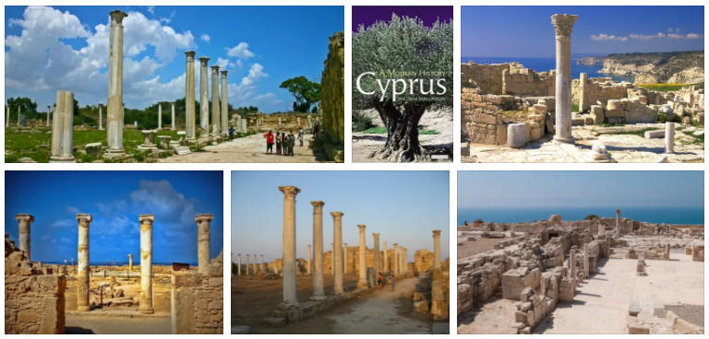
Location

Located in the centre of the ancient world and cradle of western civilization, our towns each showcase individual unique features that appeal to all group of visitors to the island.
Strategically poised at the crossroads of commercial and religious traffic between three continents, North Cyprus has hosted several civilisations over the centuries, each which have accumulated into a rich heritage throughout, all whilst maintaining its unspoilt natural beauty. Take a look for yourself… https://www.visitncy.com/

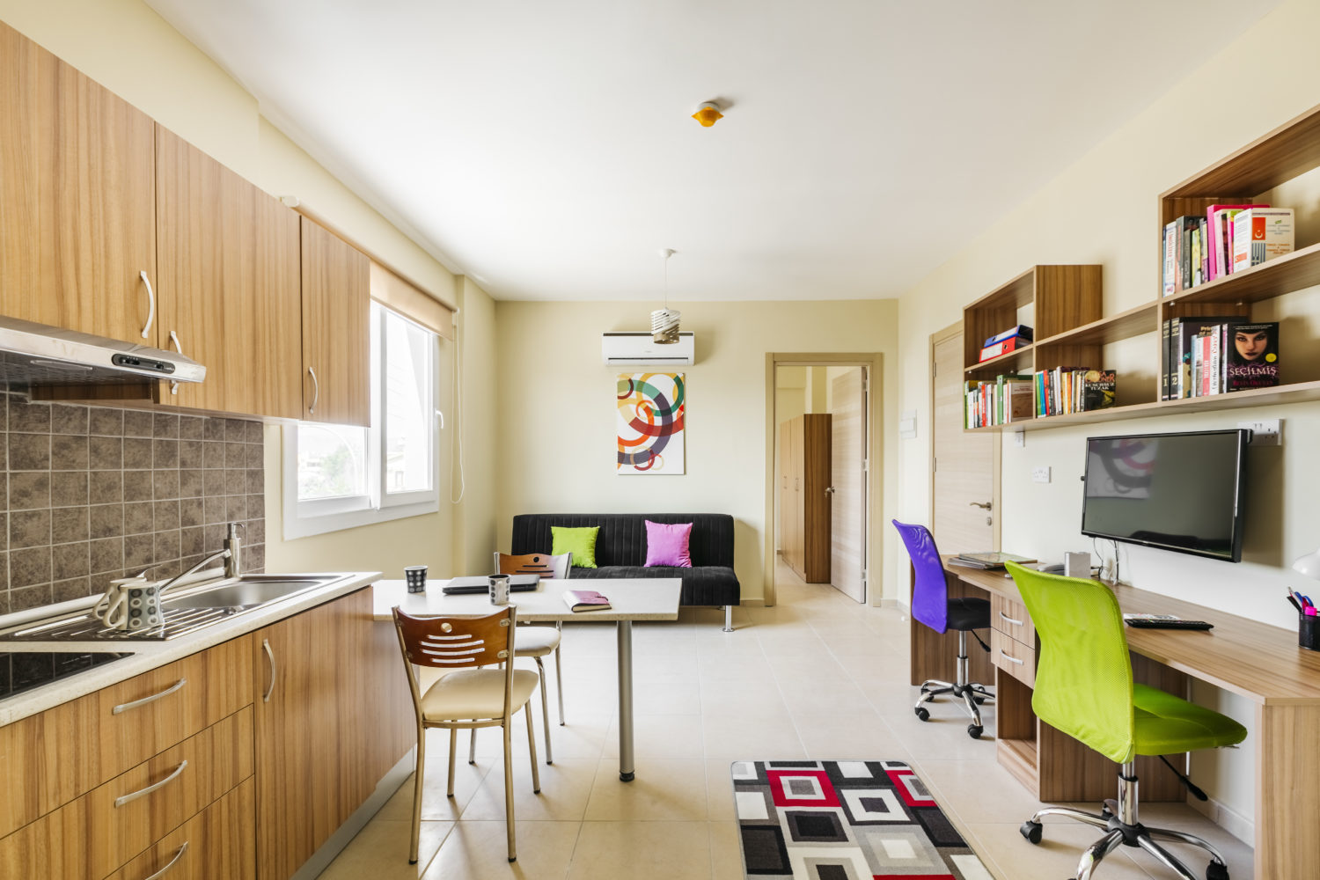
Accommodation

On-Campus | NEU provide various options for on-Campus accommodation subject to availability.  Residency services:  - Providing furnished rooms with electronic appliances  - Cleaning and maintenance services  - Internet, Water, and electricity within the rooms  - Study Hall  - Security  - Gym  - Shuttle buses between the city and the university  More information is available on: https://aday.neu.edu.tr/accommodation/?lang=en

Expenses & Budgeting
Food | Average cost of grocery items and beverages costs around 85 €/ week
Transportation | NEU offers free of charge shuttle buses between the city and the university
Visa cost / ID / Residency | Cost of Visa depends on the country of origin. Residency permit process costs around 80 €
Housing | Students may browse through accommodation options for affordable rent via https://www.hangiev.com/home and https://www.101evler.com/en
Other | Estimated average living expenses for international students are 300-500 € per month.

Additional Information

Residency Permit | A Student Residency Permit is required to remain in the country for the full duration of the study period.  Upon completion of the official registration at the International Student Office Registration Unit, the residency procedure will include:  - Status of the Students to be shared with the Ministry of Interior, Department of Immigration Office via Online Portal by the University.  - Registration of the Student to the Online Portal with personal details.  - Payment for the Residency Permit over Online Portal  - Performing a medical health check in accordance with the instructions provided by the Department of Immigration.  Upon completion of the procedures, Students are offered Digital Residency Permit.
Food Services | NEU Students are offered economic meal packages available on: https://aday.neu.edu.tr/accommodation/meal-prices/?lang=en  Students have the possibility to dine in various cafes& restaurants available on campus: https://neu.edu.tr/campus-life/canteen-restaurant-and-cafeteria/?lang=en
Campus Life | NEU provides countless possibilities for its students including but not limited to Sports Tower, Indoor Olympic Swimming Pool, Sports Centres, Laundry Service, Book Store, Market, Stationary Shops, etc.  More detail on campus life available via: https://neu.edu.tr/campus-life/?lang=en
Health Insurance | Student can obtain “Young Health Insurance” from Near East Hayat http://www.neareasthayat.com/

Social Media and Videos
Welcome to the world of Near East

What Do you want to be?

Lets have a glance at your future..

