Housing Information

Fall 2021
UNIVERSITY OF SOUTH CAROLINA
Global Carolina

Housing Application and Agreement
On-campus accommodation is guaranteed and coordinated for you. You will be assigned a dormitory for the entire semester. As part of the housing process, you will need to complete an application, sign an agreement, and obtain renters insurance.
STEP 1: COMPLETE HOUSING APPLICATION ON SELF-SERVICE CAROLINA
- Log into my.sc.edu
- Under the “Newly Admitted Student” section, select “View Housing” and Columbia Campus
- Once on the Housing page, select “Apply”
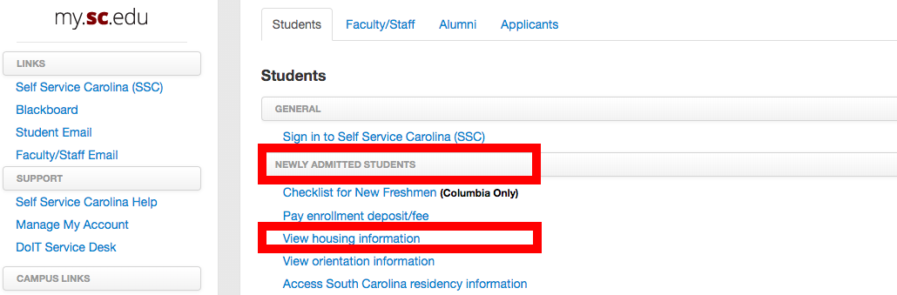
- Complete the application. Preferences will not be collected, and you should not need to select a move-in time. If you do, select any time to move to the next page.
  - You are required to purchase renter’s insurance, as part of the housing process. A link to the preferred vendor is available in the housing application. The rate for an entire year is $120.
    - If you are a semester only student, you can contact the insurance company to inquire about a possible prorated rate.
- Your permanent housing assignment will become available after you complete the housing application.

